Architecture Document:  
The technologies I’ve chosen aim to provide a robust and maintainable web application architecture. Spring Boot and MySQL ensure a strong and reliable backend, TypeScript enhances frontend development, and React simplifies the creation of dynamic and user-friendly interfaces. This combination provides a solid foundation for building a scalable and efficient web application.

C1:

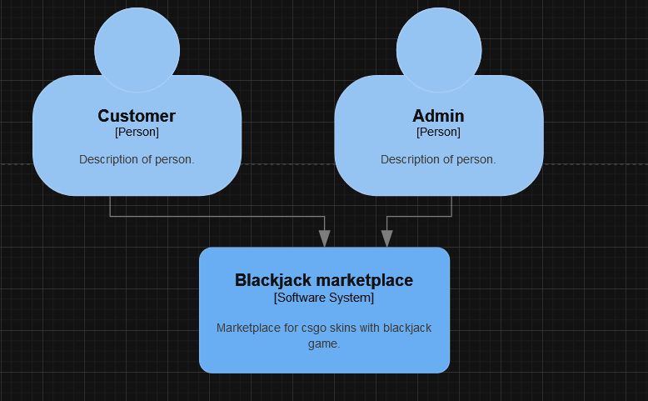

C2:

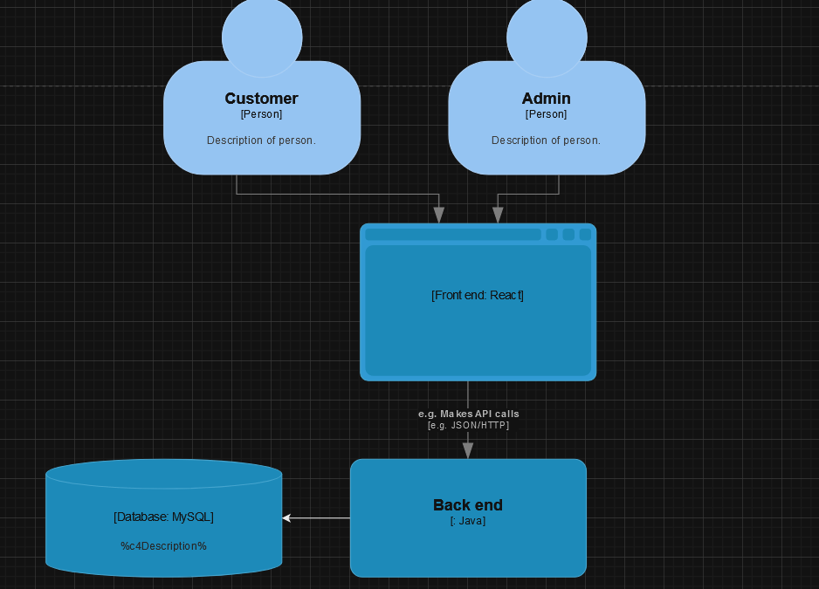

C3:

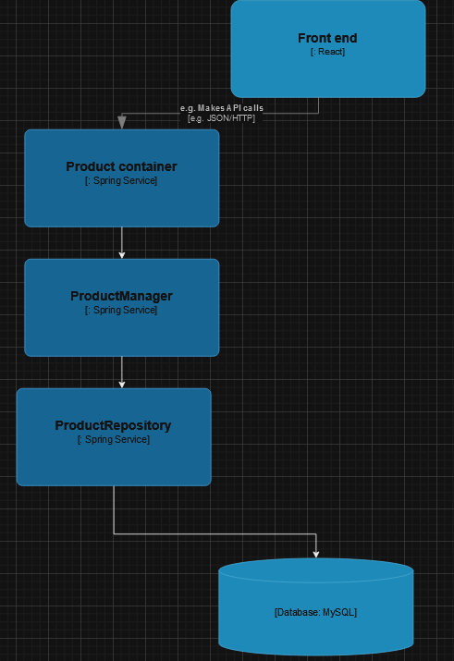

C4:

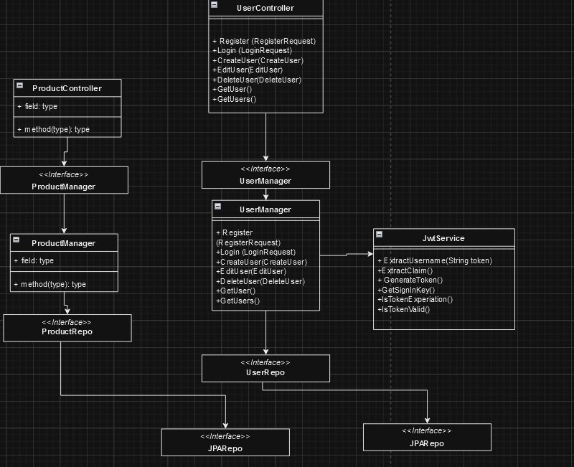

This logic applies to the whole back end.